جدول المحتويات

1. [**Background**](%5Cl%20%22_Toc80315131%22)
2. [**Goals**](%5Cl%20%22_Toc80315132%22)
3. [**Key Features**](%5Cl%20%22_Toc80315136%22)
4. [**Success Metrics**](%5Cl%20%22_Toc80315137%22)
5. [**Target Market**](%5Cl%20%22_Toc80315138%22)
6. [**Core UX Flow**](%5Cl%20%22_Toc80315141%22)
7. [**Checklist for Pre-Launch**](%5Cl%20%22_Toc80315142%22)
8. **Pricing Strategy**
9. **Anticipate Risks**
10. **Describe your competitors**
11. **Acquisition Channels**
12. Sales and customer support
13. **Proposed Solution**
14. **A/B testing**

### **Background**

Doordash is attempting to automate food delivery with the use of driving robots for orders less than 2 miles in order to reduce operational expenses and provide more regular delivery times for the more than 800K orders it receives each day. and the long-term goal is for orders to be delivered without issues and difficulties to be resolved.

**Problem**

At the moment there are no Dashers or because Dashers are busy It requires the user to wait for more. Therefore, A robot service is thus available for delivery, but for each product some faults are present, and it is possible that we expect some problems with the delivery, for example, if the order is supplied to the customer, we will find that the order is not complete or there are defects.

### **Goals**

### Create an app that allows customers to order from delivery food apps.

### Increase the number of items purchased using delivery robots.

### Reduce the amount of time users spend looking for items.

### **Key Features**

|  |  |  |
| --- | --- | --- |
| P0 | Search | Users should be able to search for a restaurant near them by entering text.  The user should be able to search for restaurants based on their name as well as their description. |
| P1 | Pickup Sharing location | Users should be able to select the nearest restaurants from the search results page.  Users should be able to share their location in order for deliveries to be made. |
| P2 | Subscriptions | Upon certain intervals, users should be able to create subscriptions to automatically buy items. We should support the following intervals: • - once a week • - once every two weeks • - once a month • - once every two months • - once every three months • - once every six months  The default setting should be every two weeks. |
| P3 | payment | Create a payment service "Doordash Pay" that enables the client to pay cash or credit cards |
| P4 | Free order | When users invite friends by code or link to the app-- they get free to order or amount. |

### 

### **Success Metrics**

• ● Launch an app that has at least 4.5 stars on the app store

• ● Increase items sold by 25%

• ● Reduce the amount of time users spend finding items by 50%

### **Target Market**

### In 2020, the total online food delivery market in the United States is expected to reach [$20.958 billion](https://www.statista.com/outlook/374/109/online-food-delivery/united-states) with over [111 million users](https://www.statista.com/outlook/374/109/online-food-delivery/united-states). Of this amount, the platform-to-consumer delivery segment will account for [$6.542 billion](https://www.statista.com/outlook/376/109/platform-to-consumer-delivery/united-states) and the restaurant-to-consumer delivery segment will account for [$14.415 billion](https://www.statista.com/outlook/374/109/online-food-delivery/united-states).

### 

### **Core UX Flow**

[Mocks](https://www.figma.com/file/TJ1tBvkDBZQ2MfQ7ktOL7R/Doordash-(Robodash)?node-id=0%3A1)

[Prototype](https://www.figma.com/proto/TJ1tBvkDBZQ2MfQ7ktOL7R/Doordash-(Robodash)?node-id=0%3A1&scaling=scale-down&page-id=0%3A1)

### **Checklist for Pre-Launch**

Allow ample time for teams to obtain approvals, prepare communications, and complete relevant training. When a new feature is added to the product, notify your teams.

**Discuss these with Marketing.**

* Our product's value proposition.
* How it solves the user's problem.
* Our product vs. the products of our competitors

**Discuss these with Customer Service.**

* Provide an overview of the product.
* Inquire about developing tools to assist the team in debugging issues for users.
* List any known bugs.

**Discuss these with** **Engineering.**

* Is there anything that has been reported as a bug?
* Are there any scenarios that should be avoided?
* Are there any workarounds that we should be aware of?

**Legal**

* Wait for feedback after giving a brief description of our service.

**Sales**

* The state's revenue target.
* Inquire about your pricing approach.

**Consult with relevant stakeholders about the potential impact on them.**

**Get your launch email ready**

**Pricing Strategy**

1. **A voucher for a free trial Delivery by robot**

We will give reductions at first, with the goal of converting 97 percent of customers to robot delivery before ceasing traditional service.

"Delivery by dasher"

1. **A Lower Cost**

The delivery of robots will reduce operational costs. We will be able to provide delivery that is 95% less expensive than standard delivery. This will increase our market share to 75%.

1. **DashRewards**

The subscription service will only be available for robot deliveries and will allow limitless deliveries. The goal is to get clients to willingly switch to it.

Revenue Objective In the first year, the goal is to boost income by 25%. To break even on development expenditures, the second year must grow by 50% more than the first. Due to easier scalability in the third year, we were able to quadruple our revenue from the previous year.

**Anticipate Risks**

1. Hardware Issues:

In everyday business, robots have not been deployed. There will be problems in the design. When a certain number of breakdowns occur, deliveries are jeopardized. We need to send in enough robots and Dashers to help.

1. Software Issues:

These issues aren't always visible and can take a long time to resolve.

The worst-case scenario would be a total blackout. We require the system's primary developers as well as a reboot plan.

1. Customers Issues:

Customers may be concerned that Dashers will lose their jobs.

The marketing team is in charge of promoting the benefits of utilizing robots and the fact that they do not endanger human lives.

**Describe your competitors**

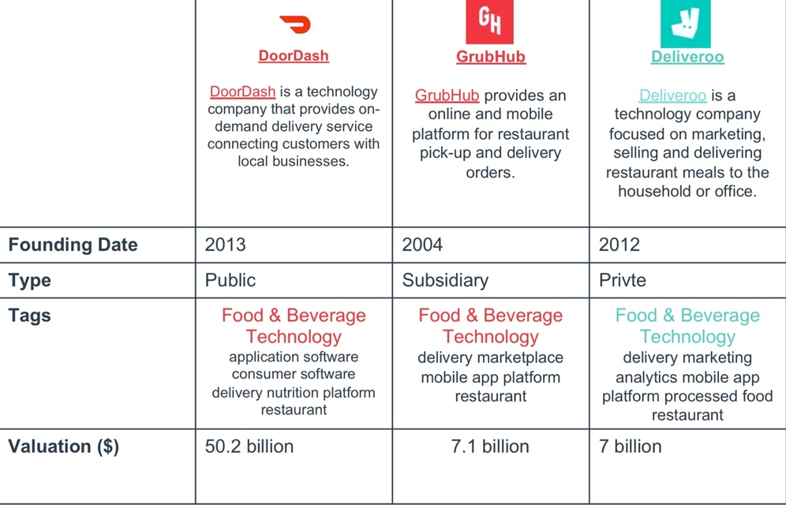

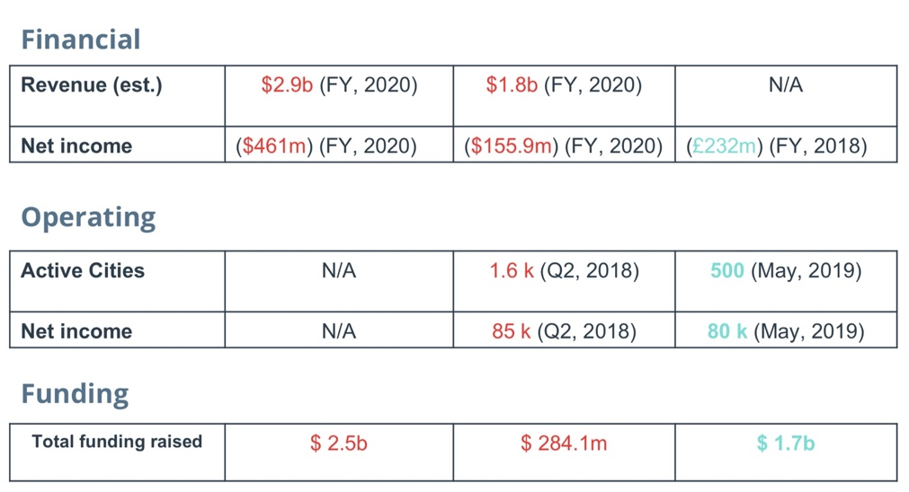

## 

**Acquisition Channels**

1. Deliverers App

Each user has to use the app. An ad is showing up when starting the app and informs about switching from choosing Dasher to delivering to choose Robot to deliver.

1. Advertisements within Social media

Since the DoorDash Software has a new delivery feature with robots

it is reasonable to show ads within these channels and having a promotion stand at the robots industry

1. 3Delivery flyer

The easiest way to promote the delivery of robots and attract new DoorDash operators is by putting promotion brochures for every delivery.

Sales and customer support

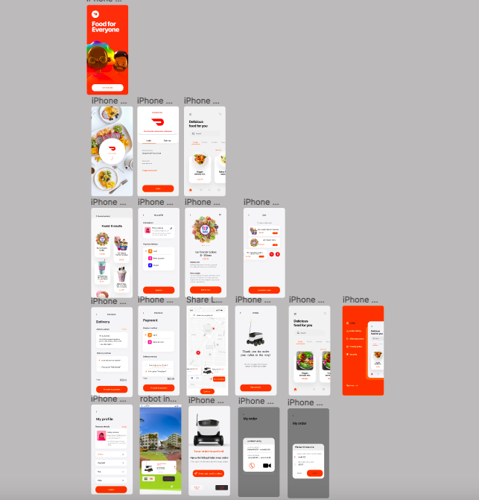

[Mocks](https://www.figma.com/file/TJ1tBvkDBZQ2MfQ7ktOL7R/Doordash-Robodash?node-id=0%3A1)

**Key Features of the Product:**

All features are essential for autonomous driving and can be accessed by the operations team

1. . Key features : send the robot back

Challenge: Avoiding and solving problems while driving by robots

Benefit: Lets the user solve problems remotely.

Where: when the order arrives, he will receive a notification. If there are problems with the order

Use: The robot will automatically return to the shop if the user clicks the first button (Robot sending)

1. Key features : Recovery money

Challenge: Avoiding and solving problems while driving by robots

. Benefit: Lets the user solve problems remotely.

Where: when the order arrives, he will receive a notification. If there are problems with the order.

Use: the user clicks the second button (recovery money), the funds will be automatically refunded to the wallet to bills in the account.

1. Key features : Robots can deliver by sensors.

Challenge: Get a feeling for the situation and auto control

Benefit: Provides more information to the operator.

Goal: Helps the robots navigating through difficult terrain.

Where: Sensor feedback is automatically shown when the remote control is started.

**Proposed Solution:**

* A UX Designer will observe the operations team.
* The Ul is probably not applicable. Furthermore, a Tester will check if the robots and software send notifications every time a malfunction happens.
* The Support team has to update the training material to raise awareness.

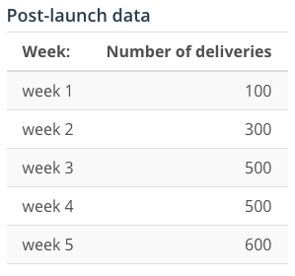

**A/B testing:**

The DoorDash Operations team will be split into 3 parts. One for reference, one with an updated User Interface and one with newbies, that are trained differently. The tester will implement updates nevertheless. If the reference group improves after another 5 weeks it is because of a software/hardware issue. You can still see if the other solutions had an impact by comparing them to the latest reference group results. Metrics will be again issues per delivery. My hypothesis is that UI needs improvement, so the operation team will not be able to miss malfunction.